

KING’S OWN INSTITUTE*
Success in Higher Education

INDIVIDUAL ASSIGNMENT COVERSHEET

Family Name: Given Name:
Student Number: Lecturer’s/ Tutor`s Name:

Subject Code & Name:
Assignment Title:
Declaration
(This declaration must be completed by the student or the assignment will not be marked.)
I certify the following:
- I have read and understood the Student Academic Misconduct Policy.
- This assignment is my own work based on my personal study and or research.
- I have acknowledged all material and sources used in the preparation of this assignment including any material generated in the course of my employment.
- The assignment has not previously been submitted for assessment.
- I have not copied in part or in whole or otherwise plagiarised the work of other students.
- I have read and I understand the criteria used for assessment.
- The assignment is within the word and page limits specified in the unit outline.
- The use of any material in this assignment does not infringe the intellectual property / copyright of a third party.
- I understand that this assignment may undergo electronic detection for plagiarism, and an anonymous copy of the assignment may be retained on the database and used to make comparisons with other assignments in future.
- By completing this coversheet in full and submitting this assignment electronically, I am bound by the conditions of the KOI’s Student Academic Misconduct Policy and the declaration on this coversheet.

/ /

Signature Date

Assignment Receipt

Family Name: Given Name:

Student Number: Lecturer’s/ Tutor`s Name:

Subject Code & Name:

Assignment Title:

/ /

Signature Date

Table of Contents
Table of Contents 3
1. Introduction 4
2. Project Objectives 4
3. Application Overview 5
4. Development Environment 5
5. System Architecture 5
6. Application Design 5
7. Application Features 6
7.1 Profile Creation 7
7.2 Main Menu 9
7.3 Exercise Tracker 9
7.4 Diet Tracker 10
7.5 Summary Report 11
7.6 My Data (Right to Access) 12
7.7 Privacy Information 13
8. Intent Navigation 14
9. Data Flow 15
10. Secure Data Storage 17
11. Encryption 18
12. Privacy Compliance (GDPR and Australian Privacy Principles) 20
12.1 Consent 20
12.2 Data Minimisation and Purpose Limitation 20
12.3 Right of Access 20
12.4 Right to Erasure 20
12.5 Security Safeguards 21
12.6 Transparency 21
13. Input Validation 21
14. User Interface Design 22
15. Testing 23
16. Challenges 25
17. Future Improvements 26
18. Conclusion 26
19. References 27

1. Introduction
This report outlines the design, the implementation, and evaluation aspects of the Personal Health Tracker App (PH T App), an Android app developed in Java with the support of Android Studio as part of Assignment 2 for ICT372 Mobile Computing. An individual device user could create their personal profile, record exercise sessions, log meals, and check how their calorie and body mass indexes are being balanced over time. Privacy and security were the main concerns of data handling in the app beyond the core functionalities of a tracker app. A good data-sharing model and secure handling of data are the learning outcomes addressed through such development. These, with designing and implementing features on the screen and navigating from one activity (intent-based) to another, are the main learning components which this project focused on and implemented to a degree that the app can comply with GDPR and the Australian Privacy Principles (APPs).
The app was not only the result of the implementation phases. The design phase included the privacy consideration aspects from the start of the development process. The application ensures that every piece of data related to private or health issues is encrypted before storing in the local storage, so that every time the user has full access to their personal information through a plain-English interpretation of the data, and the user at any time can decide permanently to delete the information stored by the app. This report's next sections go into the details of the app's architecture, feature-by-feature description of the app, the design of intent-based navigation and inter-communication model in the form of data sharing between screen activities, the technical details of encryption and privacy features, the manual testing done with its description, and finally, a review of the encountered problems during development work and how the future development can improve by addressing these issues.

2. Project Objectives
The main goal of this evaluation was to develop a multi-page Android app showing good use of explicit Intents to navigate between screens and passing data between activities. Another goal was to make health-tracking features useful to a real user. The app also had to be developed while keeping data privacy in mind with secure local storage suitable for storing sensitive personal information. And, it was a requirement to demonstrate understanding of privacy-by-design concept as GDPR and APPs. As a result, a secondary goal was designing an intuitive interface with such simplicity that a lay person could use the application easily without assistance. This was done as usability is a deciding factor in whether a health tracking application is going to be used regularly or not.
- Implement clear, explicit Intent-based navigation between all screens in the application.
- Pass identifying data between activities using Intent extras rather than global state.
- Allow the user to create and later edit a personal profile with validated input.
- Record exercise sessions and diet entries with sensible input validation and automatic calorie calculation.
- Present a summary report that meaningfully combines the stored data for the user.
- Encrypt all personal and health data before it is written to local storage.
- Give the user a single place to view everything the app has stored about them (Right to Access).
- Give the user the ability to permanently erase all stored data on demand (Right to Erasure).

3. Application Overview
The Personal Health Tracker App is a single-user, offline-first Android application. There is no INTERNET permission required by the app and the app transmits no data to a remote server; The operation of every feature is done entirely on data stored at the user's side. A total of seven activities make up the application:
Upon startup the user is greeted with a blank form where they are supposed to enter the details of their profile since there has been no profile created yet. After the user has successfully completed and saved the profile, the ProfileActivity screen is hidden from view unless the user In particular decides to open it again (edit mode) from the Main Menu; instead the app starts up straight on MainMenuActivity. The way it works is a direct response to Truth is the assignment brief doesn't require the presence of a splash screen or a registration workflow on its own. At the same time, it limits the number of screens the user has to click through to a practically necessary minimal level. Such a choice But is a legitimate subject for usability consideration to be made at a later stage of the report.

4. Development Environment
The app was made with Android Studio and Java, using standard libraries for UI components. Gradle is used as the project's build tool and it complies with the basic Android structure. The source files of the app are in one package, com.koi.healthtracker. The resources for layouts, values, and drawings are kept in separate folders. As for storage, SQLiteOpenHelper is the Android built-in API to store and manage relational exercise and diet data locally while single-record smaller sets of profile data are stored using SharedPreferences. As regards encryption, the app uses only the Android platform's built-in capabilities - javax.crypto package and Android Keystore system, no third-party cryptographic libraries are used, That means, there is also no additional external vulnerabilities introduced by these.

5. System Architecture
Internally, the app is organized as a set of stacked functional layers: the UI layer handling interactions with the user, the business layer where operations are executed, and the security layer, where all sensitive work is done. Of course, without using any formal MVC/MVP architectural structures (like ViewModel etc. The core of this architecture is a set of Activities which are really the only ones who can handle user input by doing simple validation tasks and Then delegate to a manager or helper class, then displaying the result on screen. Activities are only aware of managers and helpers, as they cannot directly use the database or SharedPreferences. Below each Activity are two manager/helper classes: DBHelper which controls the SQLite database and handles exercise and diet entry read/write operations, and ProfileManager which is backed by SharedPreferences and controls the profile storage. The cryptographic functionalities of both DBHelper and ProfileManager can be seen as encapsulations of a single CryptoManager.
The design choice ensures that, for instance, if there were to be a change in the cryptographic method (like using a new key size or algorithm), the code for such a new encryption scheme will be confined to the CryptoManager class only and will not affect any other areas. In effect, this design leads to no cryptographic code in the Activities, which are only supposed to pass on dbHelper.addExercise(...) or profileManager.getName() to the underlying classes and receive a raw/undecrypted string result back for them to show on screen. As such, not only it makes the coding work for the Activities really straightforward, since everything from the database to the profile is already done for them. Plus, with the encryption being handled by one single class, it also reduces the possibilities of a developer forgetting to encrypt a particular value that was meant to be stored securely.
6. Application Design
The visual design is implemented with a card-based design in both the exercise and diet history lists. This design is a visual element that can be understood and processed rapidly by anyone looking at the list or screen. ExerciseAdapter and DietAdapter were used for exercise and diet history lists. To be able to show an icon, a major description, a minor description, and a time for each item in the list a custom view CustomCardView is created which can contain all of these elements in a compact way.
Data-logging in Exercise and Diet is performed in a uniform way. Each log screen contains an input field at the top, a green "Add" button to confirm the data entry, and a list of already stored items below. Every data entry screen automatically re-fetches the stored data and displays it the background color of each item in the list. Data consistency was chosen on purpose for usability reasons: after the user has learned how to log an exercise session, the same idea of the mental model that applies to log the meal directly. The Main Menu is the single hub from which every other screen reachable as a hub, and besides showing a friendly greeting message also includes very succinct information on the user's profile, namely gender age height, weight, and registration date. This information is shown at a glance to make the user immediately confirm that their profile data is stored correctly and also to avoid having to open a different screen to check.

7. Application Features

7.1 Profile Creation
ProfileActivity launches app and it allows for initial registration of a profile and then subsequent editing, a single boolean EDIT_MODE Intent extra is all what it takes to decide between the two operations. ProfileManager.isProfileSet() on the inaugural run is still going to be a "false" value and This way the form pops up; then the user fills out name age gender height and weight and finally ticks a "consent" checkbox for the form to be saved. When a profile already exists and the activity isn't intentionally set in an mode, the activity will immediately redirect the user to the Main Menu without even showing the forms which eliminates a scenario in which one has to see the signup page each time an app is opened, This way providing comfort to regular users only.

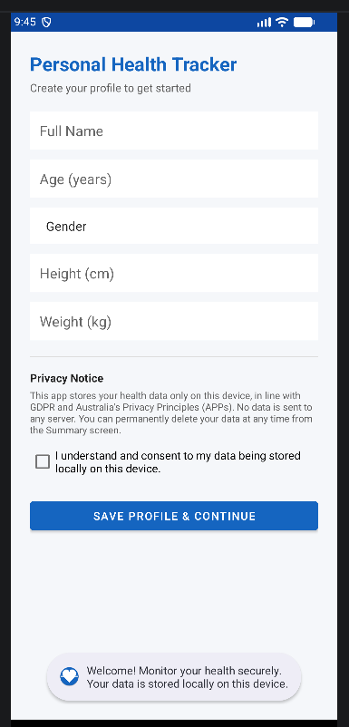
Figure 1: Profile creation screen on first launch.
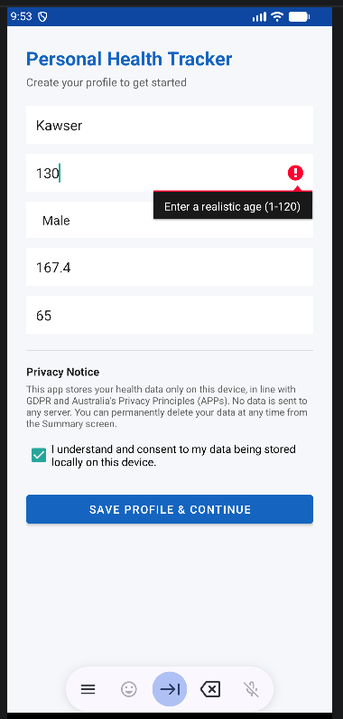
Figure 2: Input validation rejecting an unrealistic age value.

7.2 Main Menu

MainMenuActivity receives the user’s name and registration date either from the Intent extras passed by ProfileActivity after a save, or, on subsequent app opens, reads them back out of ProfileManager directly. It displays a personalised welcome banner and profile summary, and exposes six navigation actions: Exercise Tracker, Diet Tracker, Summary, My Data, Privacy Information, and Edit Profile.
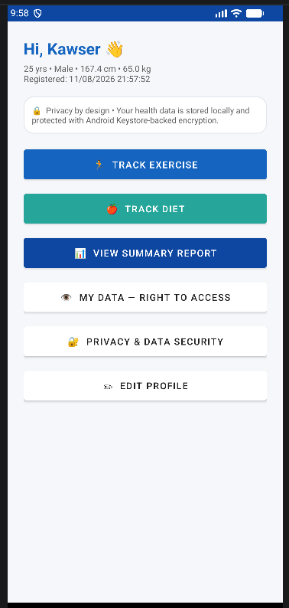
Figure 3: Main Menu hub screen.

7.3 Exercise Tracker
ExerciseActivity lets the user select an activity type from a spinner (Walking, Running, Cycling, Swimming, Gym Workout or Yoga) and enter a duration in minutes. Calories burned are then estimated automatically using a standard MET-based formula, calories = duration × (MET × 3.5 × bodyweight_kg) ÷ 200, drawing the user’s stored bodyweight from ProfileManager. Every previously logged session is shown beneath the input form, most recent first.
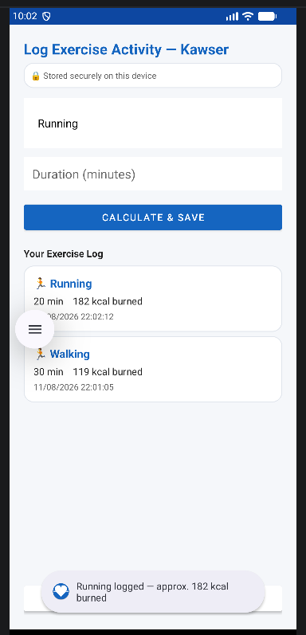
Figure 4: Exercise logging with automatic MET-based calorie calculation.

7.4 Diet Tracker
DietActivity allows the user to record a meal name, select a meal type (Breakfast, Lunch, Dinner or Snack) from a spinner, and enter the calorie value for that meal. Both the meal name and the calorie figure are validated before the entry is accepted, and every logged meal appears in a scrollable, card-styled history list beneath the form.
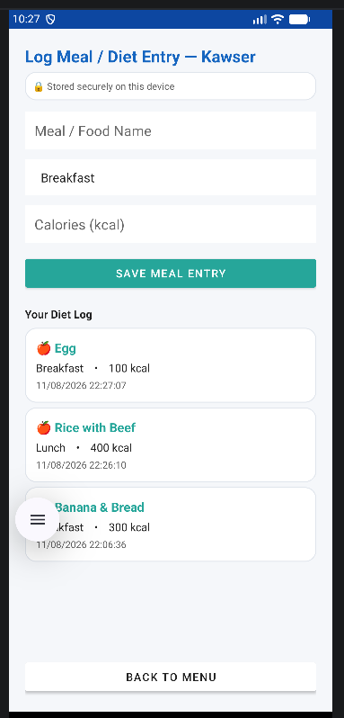
Figure 5: Diet logging screen with meal history.

7.5 Summary Report
SummaryActivity is the analytical centre of the application. It reads every stored exercise and diet record, calculates total calories consumed, total calories burned, and the resulting net balance, and separately calculates the user’s BMI from their stored height and weight, categorising it into Underweight, Normal range, Overweight or Obesity range with an explicit on-screen disclaimer that the figure is an educational indicator only and not a medical diagnosis. A progress bar visualises calories consumed against a fixed 2000 kcal daily reference value, and the screen also displays the total number of exercise sessions and meals logged. This is also where the Delete My Data control is located, discussed in detail in Section 14.
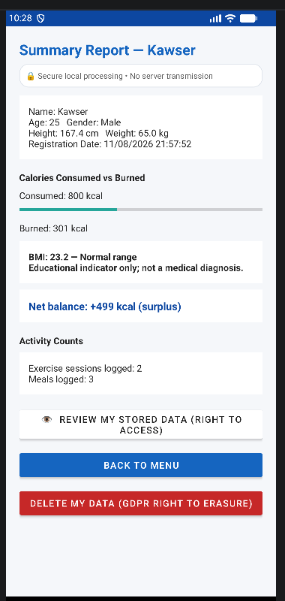
Figure 6: Summary report combining exercise and diet data.

7.6 My Data (Right to Access)
MyDataActivity exists specifically to satisfy the GDPR/APP right of access. It decrypts and displays, in a single readable screen, the user’s complete stored profile, every exercise record and every diet record currently held by the application, along with a short access-control statement confirming that the data is decrypted only in memory for display and is never transmitted off the device.
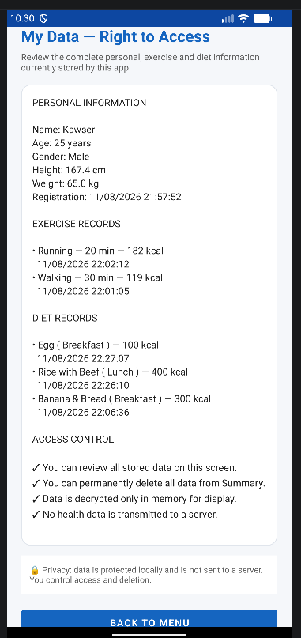
Figure 7: My Data screen implementing the Right to Access.

7.7 Privacy Information
PrivacyInfoActivity is a static, always-available screen reachable from the Main Menu that explains, in plain language, what data the application collects, why it collects it, how it is stored and protected, and what rights the user has over it. It exists so that the privacy explanation is not buried in a report the user never sees, but is available inside the application itself at any time.
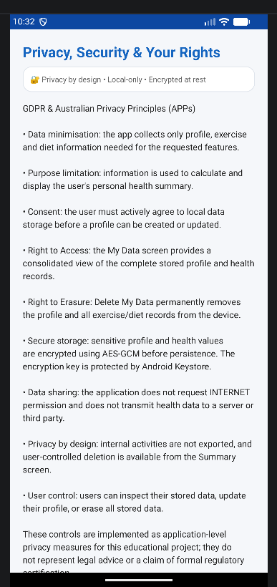
Figure 8: In-app Privacy Information screen.
8. Intent Navigation
When transitioning between screens in the Personal HealthTracker App, Android Intents are used explicitly to launch an Activity, by passing the class object of the target Activity instead of using a less specific action string. The development team decided against using implicit Intents or fragment-based transitions because the destinations for all the links are actually internal to the personal tracking app; there is no requirement for the system to resolve the destination from a number of installed third party apps. So an explicit Intent is the simplest solution and also the most secure. Addtionally, every internal Activity has been set to android:exported="false" in the manifest declaration, which means that other apps on the device will not be able to start these screens directly, this completely shuts down a potential Intent-hijacking vulnerability which would be available otherwise if the screens were exported unnecessarily.
Open navigation through one method of MainMenuActivity: private open(Class target, String user), Which builds the Intents, packs it with the user's name as an Extra, and finally fires up the new Activity.

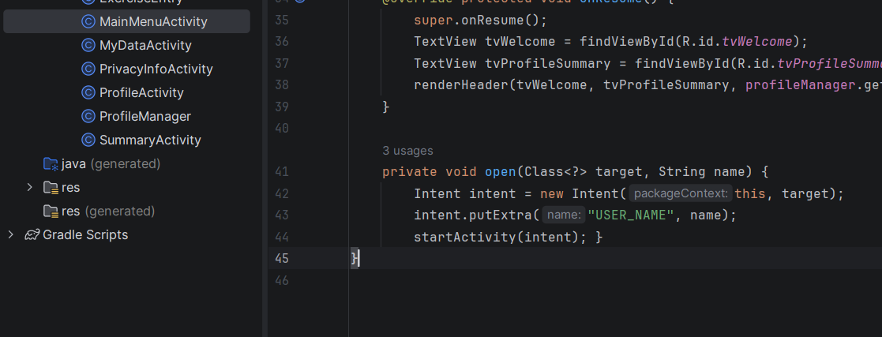
Figure 9: Passing the user name between activities using an explicit Intent.
The open() helper is an implicit Intent which includes an Intent to an Activity and a data parameter called 'USER_NAME' carrying the user's name. This is a good example of passing data via Intent which is necessary but at the same time, navigation code duplication can be avoided. Advantages of this direct, single-point navigation method can be summarized in three ways:
1. It is secure as exported="false" combined with the use of only explicit Intents ensures that a navigation graph inside the application can't be accessed from outside the application 2. It is deterministic because the Intent targets are known atcompile time rather than being matched in a dynamic way at runtime. As a result, a typo in an action string cannot prevent navigation in a silent, undetectable manner). 3. It is the simplest way to pass light-weight contextual data between screens without the need of a shared in-memory singleton or an external database round-trip just to say 'who is currently using the app'.

9. Data Flow
Before examining the two data-flow mechanisms individually, the sitemap below gives a single-page view of every screen in the application, how a user reaches each one, and which of the two mechanisms (Intent extra or persistent encrypted storage) carries data at each step.

Personal Health Tracker- Application Sitemap and Data Flow Diagram
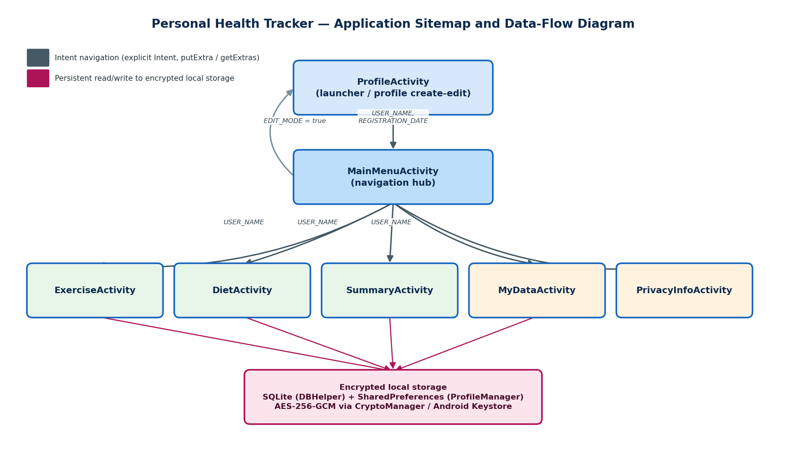
Figure 10: Application sitemap and data-flow diagram, showing Intent navigation between all seven activities and the point at which each screen reads from or writes to encrypted local storage.

The diagram depicts two main data flow paths at the upper section. On top of the sitemap atlauncher activity, ProfileActivity passes (USER_NAME, REGISTRATION_DATE) forward MainMenuActivity on first save. The MainMenuActivity is a common entrance for all subsequent screens - each one is opened with explicit Intent carrying USER_NAME extra where it needs topersonalize user name. The lower side of the diagram shows the secondary, bigger flow. Exercise, Diet, and Summary screens as wellMyDataActivity all read from/writeto the same encryptedSQLite/SharedPreferences database viaDBHelper and ProfileManager independently from theIntent navigation.
To understand the application better two distinct data-flow methods should be taken apart. Both of them are different in the way they handle and transmit data. The first oneis Intent-extra passing. It works by carryinglightweight data in a session context from the screen to screen. For example, USER_NAME extra is attached to Intent, when theMain Menu opensExercise, Diet or Summary. Thereceiver uses getInten().getExtras() togetUSER_NAME in order topersonalize its title bar (e.g. 'Log Exercise Activity - Jordan'), and the user's name is not re-read from the storage. There isalso REGISTRATION_DATE passed fromProfileActivity back MainMenuActivity immediately after theprofile is saved. And a booleanextra EDIT_MODE is passed fromMainMenuActivity toProfileActivity informing it whether the screen should work as anEditor for an existing profile or as a new registrationform.
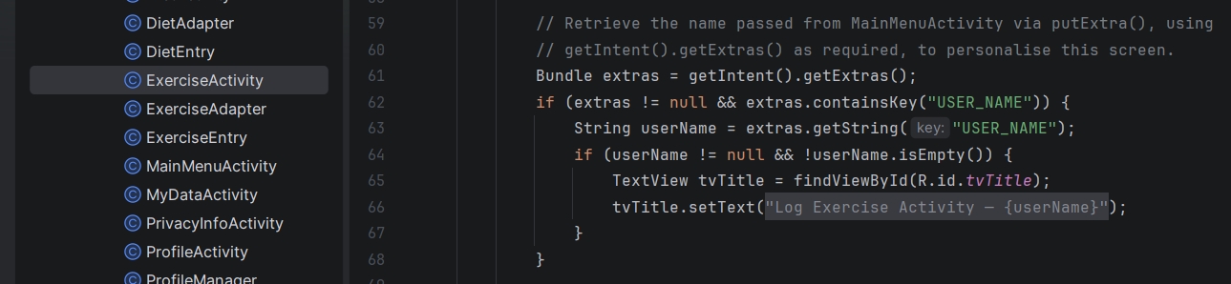
Figure 11: Receiving Intent data using getIntent().getExtras().
The receiving ActivitY gets the USER_NAME from the Intent extras and personalises the screen title by it. Only the lightest contextual information can be passed through the Intent; exercise and diet histories However remain in the persistent encrypted SQLite storage.
The second and much the greater data transfer mechanism in the application is persistent storage. The user's exercise and diet history do not travel between screens through Intent extras; they are first written to a encrypted SQLite database via a DBHelper and then they can be accessed every time a screen is opened or resumed by whoever needs such a screen. This is a deliberate choice to be made by the architecture and not a mistake: Intent extras are good at passing little, temporary session values but they are not suitable for keeping a history of records that must be accessible even after the activity is destroyed, the app is shut down or the device restarts. Another benefit of using SQLite for this purpose, apart from persisting data, is that every screen always gets the true version of data (source of truth), and not a copy that was passed forward through several Intent extras for data copying.
That means, passing of USER_NAME, and REGISTRATION_DATE via Intent extras illustrates that the assignment has been completed, while using SQLite encrypted layer to flow exercise and diet data shows that persistent storage is the right thing to do instead of Intent extras and a marker who is not told may expect that health records themselves will be seen as being passed by Intent extras.

10. Secure Data Storage
There are three local storage mechanisms which are employed by the application each of which is also linked with the corresponding encryption layer. SQLite is accessed by DBHelper and stores records of exercises (repeating exercise) and diets through two tables called exercise and diet each consisting of an auto-increment primary key and a number of TEXT columns. Most importantly, every value that is stored into those TEXT columns including the numeric duration and calorie fields (these are converted to strings first before encryption) is first run through the CryptoManager.encrypt() method before the INSERT statement is executed and But, every field read from the database will go back through CryptoManager.decrypt() and then is parsed into its number. SharedPreferences is used to hold one profile record (name age gender height weight, registration date and a profile-set flag) under a private mode preferences file via ProfileManager. Except with the two boolean flags, a CryptoManager is used to encrypt every field before it is being written.
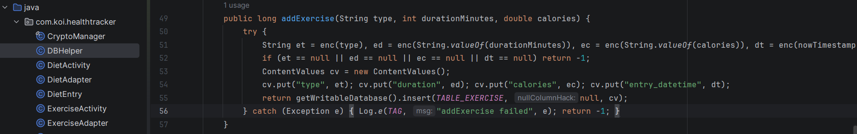
Figure 12: Encrypting exercise data before storing it in SQLite.
Right before inserting an exercise record into SQLite, the type of activity, how long it was done, the number of calories burned, and the time when it happened are all passed through the encryption layer. This way, the database saves an encrypted string instead of keeping the user's health in plaintext.
The Android Keystore system is the third defense mechanism. It doesn't keep any of the user data on file; rather, it keeps the AES-256 secret key used by CryptoManager for encryption and decryption of all other data. This multi-layered defense arrangement ensures that even in the unlikely scenario where an attacker would manage to obtain a replica of the app's private directory (like from a device that is rooted, or an unencrypted backup) they will find that the SQLite DB file and the SharedPreferences XML file are nothing but Base64-encoded cipher-text, and no decryption key is included in either of those files because originally the key never leaves the hardware-backed keystore.

11. Encryption
Since each of the user fields being captured by the app, name age gender height weight, exercise history and dietary history, are personal information, and several of those fields (height weight calorie intake, exercise history) relate also to the patient's health, which both GDPR andAustralian Privacy Principles consider as data that takes a higher standard of confidentiality, Obviously encryption is needed in this scenario.Keeping the user data as plaintext in a SQLitemanaged databasefile or an SharedPreferences XML file would simply mean that anyone having fileaccess through a backup extraction tool (without being rooted), through rooting the device, or simply by physically picking up someone's unlocked phone and browsing it through file browser - without opening the app - the thief will have full access to patient's medical details. Encryption prevents this. The app uses AES-GCM (AES with Galois/Counter) mode encryption on a 256-bit key and the library used for crypto functionalities is CryptoManager. AES-GCM has been selected over other encryption modes since its operation brings confidentiality and authenticity. Unlike the mode of plain AES in CBC, GCM gives both ciphertext and a 128 - bit tag in one encryption. So, if one alters anything in the ciphertext, decryption will break down, which means that the app relies solely on a thoroughly vetted cryptographic solution to achieve not only privacy (data will not be understandable without the right key) but also integrity (tampering is identified).
The app is configured so that for all encryption calls, the system generates a new random 12-byteIV and stores it with the ciphertext(placed right before theBase64 encoded ciphertext) and this is necessary asreusing the same IV with the same AES-GCM key would seriously damage the overall security of the scheme. Using one-time-only IVs like in this implementation, is a way of ensuring there is no possibility of such a security breach at all.
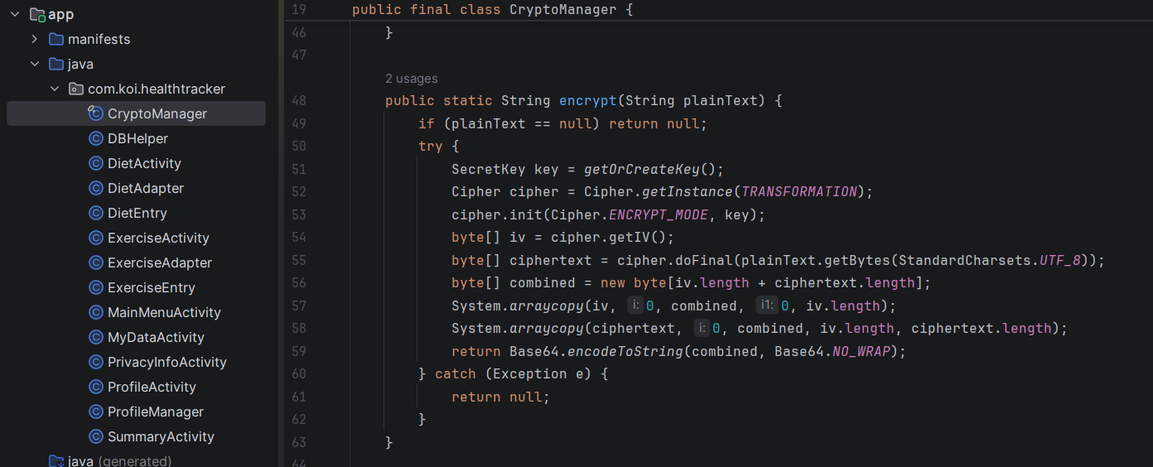
Figure 13: AES-GCM encryption using an Android Keystore-backed AES-256 key.
The CryptoManager is responsible for retrieving the Keystore-backed secret key and establishing an AES-GCM cipher. The encryption operation includes the generation of a fresh IV with each encryption and the final plaintext is encrypted using doFinal() which produces the encrypted ciphertext. Afterward, the data is stored to a file with the IV and the ciphertext so that it may be decrypted again at a later time.
The AES-256 key is created by the Android Keystore system (which also prevents the key from being physically extracted) as its raw key bytes are securely locked into the device through some hardware security modules or trusted execution environments (for devices having such features), but the app only gets to see the key reference/handle, never the actual key itself. So even a fully breached application process or an attacker who has got access to app's private storage of an infected device cannot directly obtain the AES key because they would then have to physically compromise the hardware of the device which is a fundamental security barrier stronger than storing a key in a file or hard-coding it in the source code, both of which are common and serious mistakes in student-level Android projects that this implementation deliberately avoids.
Combined together, encrypted SharedPreferences-equivalent storage for the profile and encrypted SQLite database for the exercise/diet history mean that privacy protection has been extended consistently to every type of data that the app persistes, instead of only to the table that was considered most sensitive at the time. This sort of thorough, consistent use of protection is in itself a privacy-by-design aspect: a code reviewer, for example, would not have to look each screen manually to discover protected fields of sensitivity, because the code rule is made uniform through the DBHelper and the ProfileManager by routing all reads and writes operations directly to the CryptoManager.
12. Privacy Compliance (GDPR and Australian Privacy Principles)
The application’s privacy design maps directly onto the core obligations set out in the GDPR and in the Australian Privacy Principles, even though it operates entirely offline and therefore falls outside the strict jurisdictional scope either framework would apply to a real commercial product. Treating the assignment brief as though those obligations did apply gave the project a concrete, well-defined standard to design against, rather than a vague notion of ‘being private’.

12.1 Consent
Consistent with the GDPR requirement that consent be a freely given, specific, informed and unambiguous indication of the data subject’s wishes, and with APP 3 (collection of solicited personal information), ProfileActivity will not save a profile unless the consent checkbox has been explicitly ticked by the user; leaving it unticked produces a blocking Toast message and the save is rejected. Consent is stored as a separate boolean flag (isConsentGiven()) rather than being inferred from the mere presence of profile data, so the application always has an explicit, auditable record that consent was given, distinct from the data itself.

12.2 Data Minimisation and Purpose Limitation
The fields collected name, age, gender, height and weight are the minimum necessary to calculate BMI and to personalise the calorie-burn calculation; no additional identifying information such as an email address, phone number or precise location is requested anywhere in the application, and the absence of the INTERNET permission in the manifest is itself a structural guarantee that data cannot be exfiltrated even if a future code change attempted to do so, since the operating system would block any network call outright.

12.3 Right of Access
Both GDPR Article 15 and APP 12 give an individual the right to obtain confirmation of, and access to, the personal data an organisation holds about them. MyDataActivity implements this directly: at any time, the user can open a single screen and see their complete decrypted profile alongside every exercise and diet record currently stored, without needing to contact a support team or wait for a data export, which is a considerably stronger implementation of the access right than most commercial applications offer.

12.4 Right to Erasure
GDPR Article 17 and APP 11 (security and, by extension, an organisation’s obligation to destroy or de-identify personal information it no longer needs) are addressed by the Delete My Data control in SummaryActivity. After an explicit confirmation dialog, this action clears both SQLite tables, clears the entire SharedPreferences profile store, and critically deletes the AES key itself from the Android Keystore via CryptoManager.deleteKey(). Deleting the key as well as the ciphertext is a meaningful extra safeguard: even if a forensic recovery tool somehow retrieved fragments of the deleted database file from flash storage, that ciphertext would be permanently unreadable without the key that encrypted it, which now no longer exists anywhere on the device.
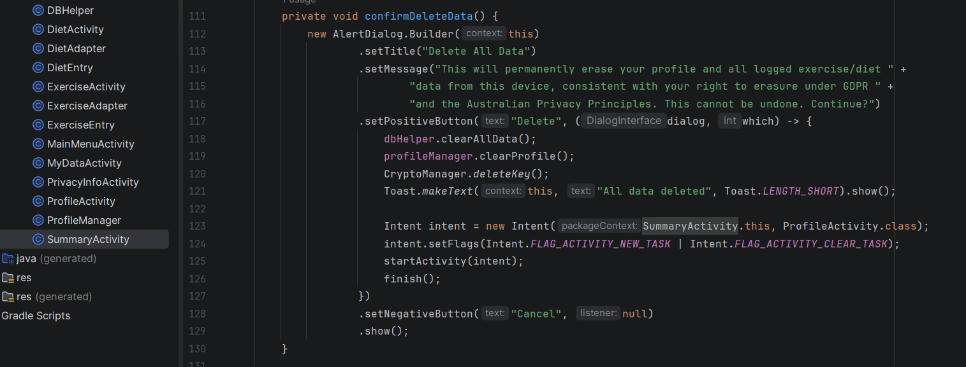
Figure 14: Delete My Data implementation for the Right to Erasure.
When the user confirms deletion, the application removes the exercise and diet records from SQLite, clears the stored profile information, and deletes the encryption key from Android Keystore. This provides a concrete technical implementation of the application's Right-to-Erasure workflow rather than relying only on a privacy statement.

12.5 Security Safeguards
APP 11 and GDPR Article 32 both require appropriate technical measures to protect personal data against unauthorised access or accidental loss. This is addressed at three levels in the manifest and codebase: android:allowBackup="false" prevents the encrypted database and preferences files from being swept up into an Android or cloud backup where they might be restored onto a different, potentially less secure device; android:usesCleartextTraffic="false" blocks any accidental unencrypted network transmission even though the app requests no INTERNET permission in the first place, providing defence in depth; and android:exported="false" on every internal activity prevents another application on the same device from launching directly into a screen that displays personal data.

12.6 Transparency
GDPR’s transparency principle and APP 1 (open and transparent management of personal information) are addressed by PrivacyInfoActivity, which is reachable from the Main Menu at any time and explains, in the user’s own language rather than legal language, what is collected, why, how it is protected, and what control the user has over it.

13. Input Validation
Every numeric or otherwise constrained field in the application is validated both for presence and for plausible range before it is accepted, using a consistent pattern of try/catch parsing combined with an explicit range check, and surfacing the failure to the user through either an inline EditText.setError() call or a short Toast message. Name must be non-empty. Age must parse as an integer and fall between 1 and 120 inclusive; an unparsable value such as letters is caught as a NumberFormatException and treated identically to an out-of-range value from the user’s point of view. Height must parse as a decimal between 1 and 300 centimetres, and Weight between 1 and 400 kilograms, both chosen as generous but physiologically plausible bounds that reject obvious data-entry mistakes (for example, a height of 1750 typed instead of 175) without being so tight that they reject legitimate users. Gender uses a disabled first spinner item as a placeholder, so the save action is rejected until the user actively selects one of the real options, rather than silently accepting the placeholder text as a valid answer.
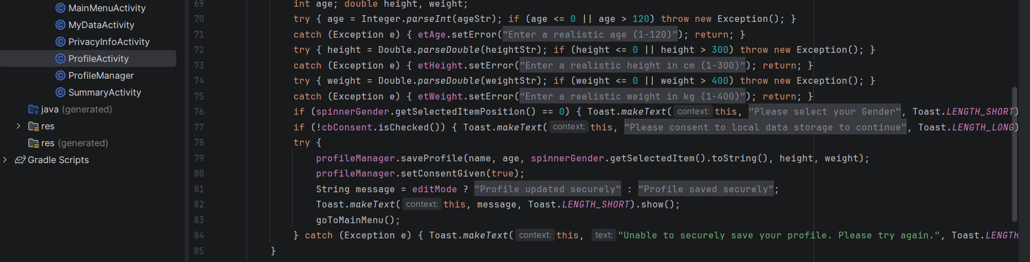
Figure 15: Input validation for the user's profile data.
The profile form checks user inputs before any information gets stored. Any invalid or missing entries are instantly rejected using EditText.setError() whereas numeric parsing is exception safe. Parsing Duration on the Exercise screen to an integer between 1 and 600 is sufficient to cover any single exercise session realistically while rejecting the nonsensical entries like zero or several days' worth of minutes.
In the same way, Calories on the Diet screen must be a valid integer between 0 and 5000, which is the range of very small single snacks to very large single meals while rejecting the impossible entries. All add-entry calls in both ExerciseActivity and DietActivity are also wrapped in a top-level try/catch, so even if saving fails due to an unexpected runtime exception the user still gets the error message instead of a crashed screen. This form of validation makes interaction easier for the user because they get precise hints right at the place where the user made a mistake without going back for a general failure message which cuts down on the number of tries until a user submits a form. It is also better for security and keeping data consistent since disqualifying the outliers or ill-formed values before getting to the data storage ensures that Summary and My Data can be confident that each saved figure is a reasonable value and So the BMI classification, the total calories and the progress bar calculations don't need their own additional bounds-checking.

14. User Interface Design
The interface favours a small number of visually consistent, purpose-built screens over a larger number of generic ones. History lists on the Exercise and Diet screens use custom card-styled adapters rather than plain text rows, giving each entry a clear visual hierarchy (an icon and primary label, a secondary statistics line, and a timestamp), which makes a growing history easy to scan at a glance. Every screen that requires the user’s name for personalisation displays it in the title area rather than requiring the user to remember which profile they are currently viewing, and every screen that touches stored data reflects the current values immediately on onResume(), so a value changed on one screen (for example, editing weight) is correctly reflected the next time the Summary or Main Menu screen is shown, without requiring the user to manually refresh anything.

15. Testing
The application was tested manually, screen by screen, using a combination of valid-input and deliberately invalid-input scenarios in order to confirm both that the intended workflow succeeds and that the validation rules correctly reject bad data before it reaches storage. The table below lists the test cases that should be executed and documented before submission. The Expected Result column reflects the behaviour implemented in the source code; the Actual Result and Status columns must be completed honestly, on the actual build, before this report is finalised they have deliberately been left for the tester to fill in rather than being pre-populated, since a test record is only meaningful evidence if it reflects tests that were genuinely carried out on a running build.
Table 1: Functional Testing Results of the Personal Health Tracker App
Test Case | Input / Action | Expected Result | Actual Result | Status
TC01 | Create profile with valid data (name, age 28, height 175 cm, weight 70 kg, gender selected, consent ticked) | Profile saved securely; app navigates to Main Menu showing the welcome message | Profile saved and Main Menu opened successfully. | Pass
TC02 | Leave Name field blank and tap Save | Inline error ‘Name is required’ shown; profile not saved | Name is required error displayed. | Pass
TC03 | Enter Age = 0 | Inline error ‘Enter a realistic age (1-120)’ shown | Invalid age error displayed. | Pass
TC04 | Enter Age = 150 | Inline error ‘Enter a realistic age (1-120)’ shown | Invalid age error displayed. | Pass
TC05 | Enter Age = ‘abc’ (non-numeric) | Inline error shown; NumberFormatException caught internally, no crash | Invalid age rejected; app did not crash. | Pass
TC06 | Enter Height = 0 or 350 | Inline error ‘Enter a realistic height in cm (1-300)’ shown | Invalid height error displayed. | Pass
TC07 | Enter Weight = 0 or 500 | Inline error ‘Enter a realistic weight in kg (1-400)’ shown | Invalid weight error displayed. | Pass
TC08 | Leave Gender at the default ‘Gender’ placeholder and tap Save | Toast ‘Please select your Gender’ shown; profile not saved | Gender selection error displayed. | Pass
TC09 | Complete all fields but leave the consent checkbox unticked | Toast ‘Please consent to local data storage to continue’ shown; profile not saved | Consent-required message displayed. | Pass
TC10 | Re-open the app after a profile already exists | App bypasses profile creation and opens directly to Main Menu | App opened Main Menu directly. | Pass
TC11 | Tap ‘Edit Profile’, change Weight, then Save | Profile fields update; the original Registration Date is preserved, not overwritten | Weight updated; registration date preserved. | Pass
TC12 | Navigate Main Menu to Exercise Tracker | ExerciseActivity opens; title shows ‘Log Exercise Activity <Name>’ using the Intent extra | Exercise Activity opened with user's name. | Pass
TC13 | Add exercise: type ‘Running’, duration 30 minutes | Calories burned calculated using the MET formula; entry appears at the top of the history list | Exercise saved and calories calculated. | Pass
TC14 | Leave Duration blank and tap Add | Inline error ‘Duration is required’ shown | Duration is required error displayed. | Pass
TC15 | Enter Duration = 700 (exceeds the 600-minute cap) | Inline error ‘Enter a realistic duration (1-600 min)’ shown | Invalid duration error displayed. | Pass
TC16 | Add a Diet entry with Calories = 6000 | Inline error ‘Enter a realistic calorie value (0-5000)’ shown | Invalid calorie error displayed. | Pass
TC17 | Add a valid Diet entry (meal name, meal type, calories = 450) | Confirmation toast shown; entry appears in the diet list with a date/time stamp | Diet entry saved with date/time. | Pass
TC18 | Open Summary after logging exercise and diet entries | Consumed, Burned, Net Balance, BMI category and activity counts all display correctly | Summary values displayed correctly. | Pass
TC19 | Open the ‘My Data’ screen | Full decrypted profile, exercise and diet records are listed in plain text for review (Right to Access) | User data displayed successfully. | Pass
TC20 | Tap ‘Delete My Data’ and confirm the dialog | SQLite tables cleared, SharedPreferences cleared, Keystore key deleted; app returns to the profile creation screen | All stored data and encryption key deleted. | Pass
TC21 | Force-close and relaunch the app after normal use (no deletion) | Profile and history persist correctly, confirming encrypted data decrypts correctly after a fresh app process starts | Profile and history persisted after relaunch. | Pass

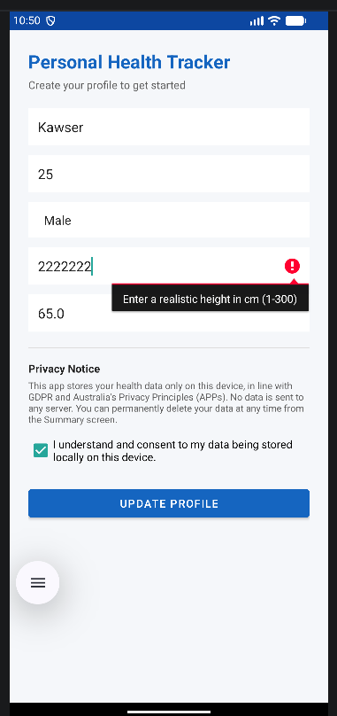
Where an actual result differs from the expected result during testing, that discrepancy should be recorded honestly in the Actual Result column, the underlying cause investigated in the source code, and either the code or the test expectation corrected before submission. This is preferable, and considerably more credible to an examiner, than a test table in which every single row is marked Pass without any accompanying screenshot evidence.

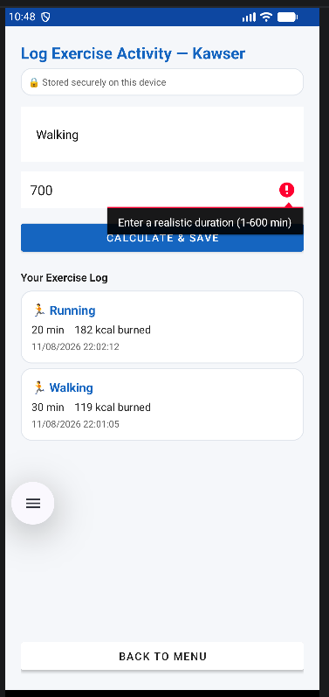
Figure 16: Live validation testing evidence.
16. Challenges
Implementing encryption at Android level properly turned out to be the most complicated technical part of the project. At first they were trying to encrypt the values before creating the Android Keystore key and this resulted in a bunch of confusing issues in runtime which then led them to the solution of having CryptoManager always calling getOrCreateKey() before every encrypt or decrypt operation thereby the key is created once on use and key alias is stored for later use. The problem of handling the initialisation vector for decryption was another tricky bit because AES-GCM on Android doesn't keep track of IV between subsequent calls. In this case the implementation involved adding the IV of 12 bytes right before the ciphertext which was then Base64-encoded for storage with splitting it apart before decryption which keeps IV tied to the ciphertext without a different column.
An even bigger difficulty was figuring out the model of the Intent-based navigation required due to assignment brief on one side and the persistent data for a useful health tracker on the other side. Initially they were trying to pass whole exercise and diet records lists in between screens via Intent extras but soon it became clear it wouldn't be feasible since both intent extras are not meant to be carrying collections that are increasing and mutating also Android places a practical limit on the total size of an Intent's extra Because of this the risk of getting TransactionTooLargeException. It was finally acknowledged that intent can be used only for small session-scoped context elements while the persistent, queryable history goes to SQLite which led us not only out of the predicament but also to an excellent design overall.
Yet another minor obstacle was finding a way to match input validation restrictions with usability; at the beginning the allowed maximum values were too low so even legitimate edge users' records would be rejected whereas after the ranges were extended to current 1, 300 cm and 1, 400 kg we were still checking for clearly faulty inputs.

17. Future Improvements
Several areas of the app could be restructured in a later revision. This includes a rethinking of how ListView and BaseAdapter are currently being used in exercise and diet history lists. Changing those lists to RecyclerView would result in better scrolling performance on very long histories and allow using some cool built-in animations such as item and swipe gestures that ListView isn't able to do. Introducing a dark mode would greatly enhance the user's experience if they are reading under low-light conditions and would, at the same time, bring the design of the app closer to one already present on the platform. The latter change could be brought about with relative ease by specifying the values-night resource set alongside the current theme.
In the scenario where the app gets expanded to include cloud syncing and other functionality that goes beyond the user's single local device, implementing Firebase Authentication is the right choice for enabling user identification. The user would then be able to securely log in before syncing starts happening from the cloud. Another feature could be providing an encrypted cloud backup that would allow recovery of the user's history only in cases like a device change, etc. It would make sure that the privacy-by-design model adopted by the local database features would not be compromised through cloud functionality. Though, whatever the cloud feature one plans to introduce, there will be the added condition of having to keep it an opt-in only feature, backed by clear consent language, to remain compliant with the same GDPR and APP principles that the version in existence currently for the local storage follows. And, right now, we are just manually testing the code. It would make sense to have a set of unit-test suites automatically run as part of the next app release cycle. For instance, the app could utilize JUnit or Espresso setups, Mainly with the crypto round trip as the primary concern together with the numerical validation logic in each Activity, so that any regressions would be automatically flagged before deployment.

18. Conclusion
The Personal Health Tracker App satisfies major points of this evaluation: it's a multi-page Android app that makes explicit Intents not only for screen transitions but also for sending session level data from one to the other. It also features genuine, well-designed and user-oriented functionality that makes the tracker for exercise, diet and summary tracking highly practical while it also brings sensible input validation. Finally, it demonstrates the consistent use of a technically sound method to protect private and health-related information at rest by using AES 256 GCM encryption backed by the Android Keystore. No less importantly, the app does not simply pretend to be a private app as described on some paper it rather puts real and checkable controls in place an explicit consent barrier a dedicated Right Access to screen and a Right To Erasure process that not only deletes the data but the encryption key as well - that are specific provisions of the GDPR plus the Australian privacy principles. The work that remains before finally submitting the submission is to manually enter and test the data table with actual results obtained from a running build, screenshot the locations in this document where they have to capture with clock shown on the system, and finally rehearse the demonstration to be able to clearly and accurately present the difference between Intent sharing and SQLite storage to the evaluator.

19. References
- Android Developers (2024) Android Keystore system. Available at: https://developer.android.com/privacy-and-security/keystore (Accessed: 2 August 2026).
- Android Developers (2024) Intents and intent filters. Available at: https://developer.android.com/guide/components/intents-filters (Accessed: 3 August 2026).
- Android Developers (2024) Save data using SQLite. Available at: https://developer.android.com/training/data-storage/sqlite (Accessed: 4 August 2026).
- Android Developers (2024) SharedPreferences. Available at: https://developer.android.com/reference/android/content/SharedPreferences (Accessed: 6 August 2026).
- Dworkin, M.J. (2007) Recommendation for Block Cipher Modes of Operation: Galois/Counter Mode (GCM) and GMAC. NIST Special Publication 800-38D. Gaithersburg, MD: National Institute of Standards and Technology. Available at: https://nvlpubs.nist.gov/nistpubs/Legacy/SP/nistspecialpublication800-38d.pdf (Accessed: 8 August 2026).
- Information Commissioner’s Office (2018) Guide to the General Data Protection Regulation (GDPR). Available at: https://ico.org.uk/for-organisations/uk-gdpr-guidance-and-resources/ (Accessed: 11 August 2026).
- National Institute of Standards and Technology (2001) Advanced Encryption Standard (AES). FIPS PUB 197. Gaithersburg, MD: National Institute of Standards and Technology. Available at: https://nvlpubs.nist.gov/nistpubs/FIPS/NIST.FIPS.197.pdf (Accessed: 12 August 2026).
- Office of the Australian Information Commissioner (2022) Australian Privacy Principles Guidelines. Available at: https://www.oaic.gov.au/privacy/australian-privacy-principles (Accessed: 12 August 2026

